Final Memo
This final analysis aims to detect and reduce e-commerce delivery fraud at Walmart by analysing delivery data from Central Florida. The goal is to identify patterns indicating items marked as delivered but not received by customers. The findings will help create a model to minimize theft and fraud across all U.S. regions.
With our research, we could find crucial insights for higher stakeholders, facilitating the process of decision-making. In this memo, we’ll only display charts and conclusions we found while treating and analysing the data provided by the company. Later, we’ll also recommend next research with the aim to get more data and, consequently, better analysis with more accurate insights.

Recommendation 1
While analysing the total lost per region, we could identify an interesting pattern. The regions of Orlando, Altamonte Springs and Winter Park are responsible for almost 50% of our total losses. These three areas are what we considered “critical regions”.
In the chart below we can see the result of our analysis:
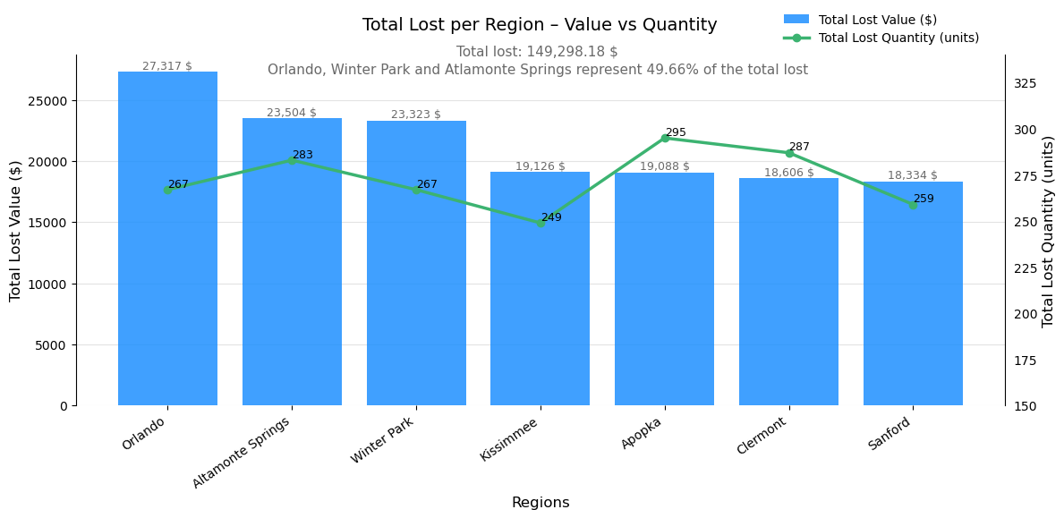
With this visualization, the company should focus more of its focus on these top 3 areas, considering them a tier 1 priority. In those areas, we recommend the company to enforce the next recommendations.

Recommendation 2
During our EDA process, we segmented drivers and customers using a method of score. The highest the score, the riskier the customer/driver. Our score rules were:
- Recurrency based of average: If the customer/driver had a higher number of incidents with lost packages, it would receive 1 point of fraudulence probability.
Total Lost: To categorize the drivers/customers we found a standard value located at the 2nd and 3rd quartile (50%). For the customers, the value was 60$ and for the customers the value was 105$.
Average Loss Ticket: To categorize the drivers/customers we found a standard value located between the 2nd and 3rd quartiles (50% and 75%). For both of them, the value was 60$.

